BOOK STORE DOCUMENTATION-USER MANAGEMENT

By

V. Sai Shiva Kumar

Use Case Diagram

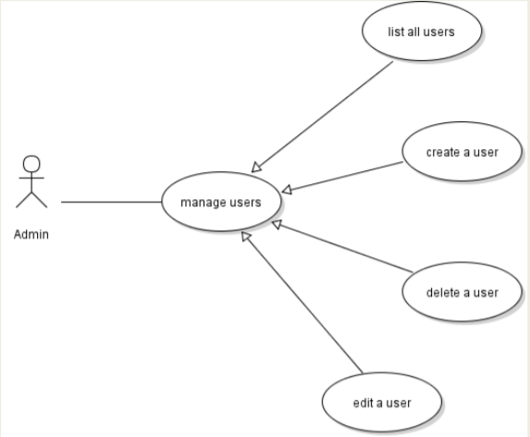

CLASS DIAGRAM FOR USER MANAGEMENT

UserManagement

userID: string //autogenerated

fullName:string

emailId:string,

password: string,

createdDate: LocalDate,

updatedDate: LocalDate

ADMIN Login

emailId: string,

password: string

Create,

update, delete, view

SEQUENCE DIAGRAM:

UserDao

UserServiceImpl

UserWebController

Admin

Logs in as

Admin and performs a CRUD

Operation and the request

Will be directed to the method for particular

webcontroller crud operation in service

is accessed

checks for the data and if data

is present in database and

processes the request

Required data will be sent